Using the Bar (Word Problems – All ages)
The bar represents the problem when you don’t know how to solve it
It reveals which operation(s) is needed to solve the problem
It does not calculate the answer for you. You need to know calculation methods.

Children need to become confident at representing problems with bars / cuisinaire rods, when they are young so that they can draw on it as a strategy later on. Eventually they reach a point where they draw the bar only if they need to because they don’t know which operation(s) to use otherwise.
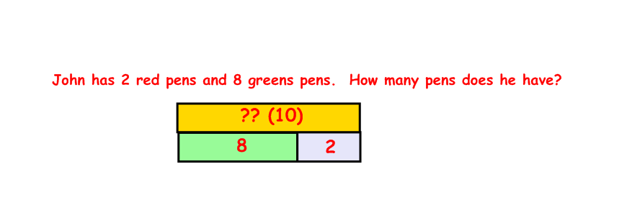
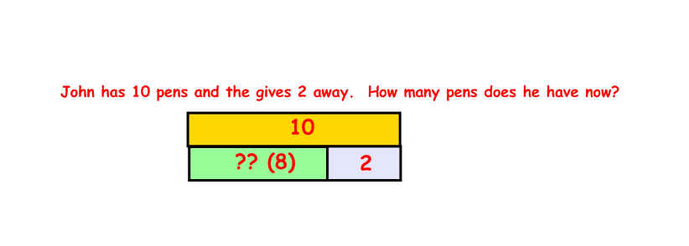
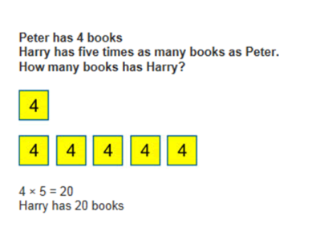
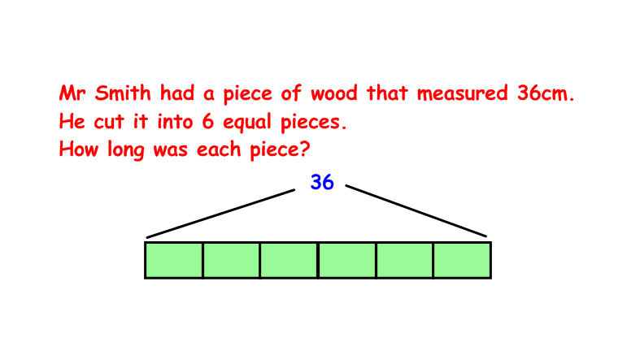
SOME EXAMPLES

Using the Bar (Fractions)
The bar again provides a visual reference point. This makes it easier to see what is happening. Once they can see what is happening they might be ready to move onto just using numbers, but hopefully with a firm understanding of why something is done.
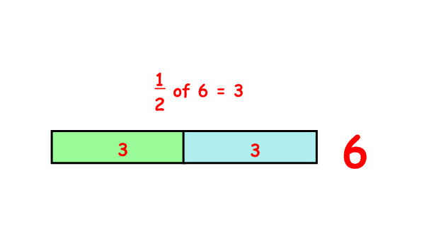
Stage 2
Begin representing fractions with bar image
e.g.

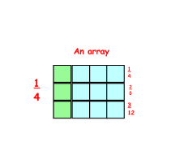
Stage 3
Recognise and show, using diagrams, equivalent fractions with small denominators.

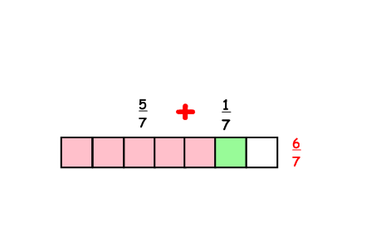

Add and sub fractions with the same denominator within one whole (e.g. ⁵∕₇ + ⅟₇ = ⁶∕₇).

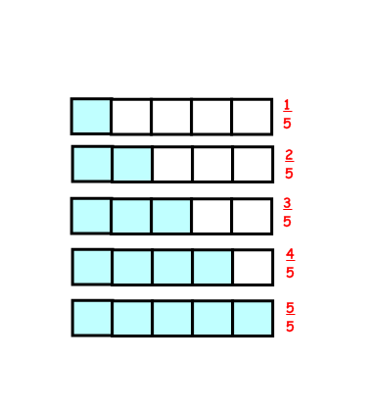

Compare and order unit fractions, and fractions with the same denominators.
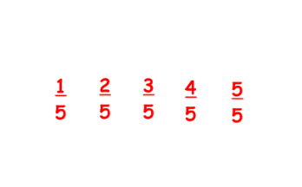

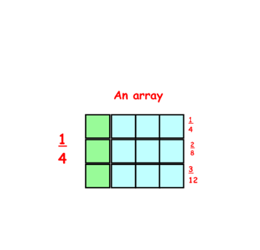
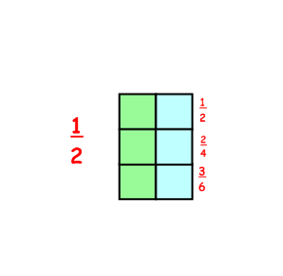
Stage 4
Recognise and show, using diagrams, families of common equivalent fractions.

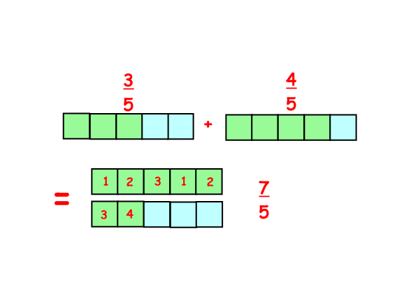
Add and subtract fractions with the same denominator

.

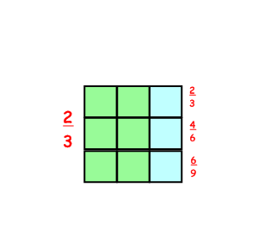
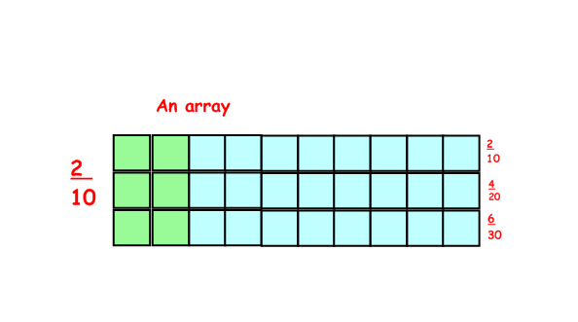
Stage 5
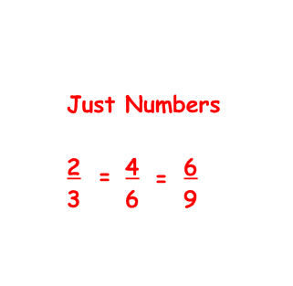
Identify, name and write equivalent fractions of a given fraction, represented visually, including tenths and hundredths.

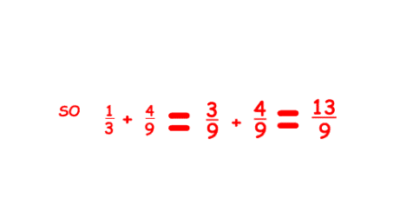
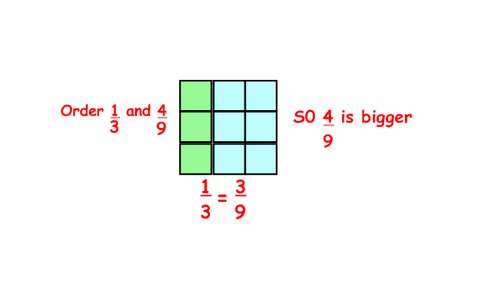
Compare and order fractions whose denominators are all multiples of the same number. Add and subtract fractions with the same denominator and multiples of the same number.

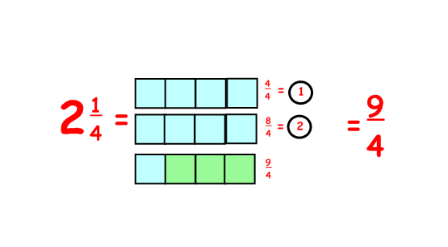
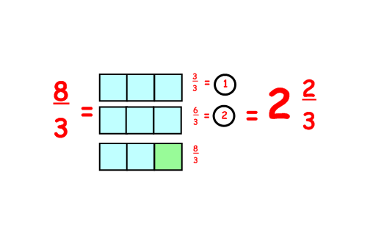
Recognise mixed numbers and improper fractions and convert from one form to the other and write mathematical statements > 1 as a mixed number.
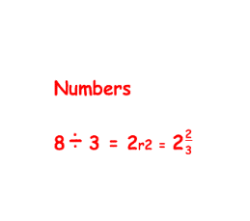

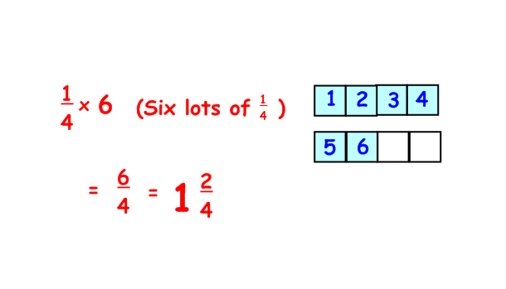
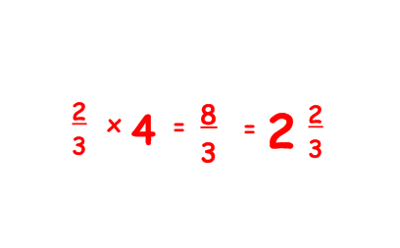
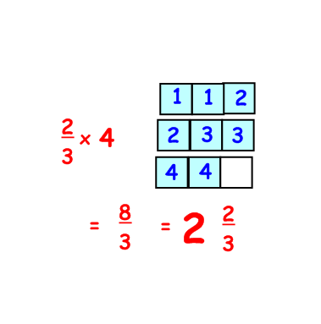
Multiply proper fractions and mixed numbers by whole numbers, supported by materials and diagrams.

Stage 6

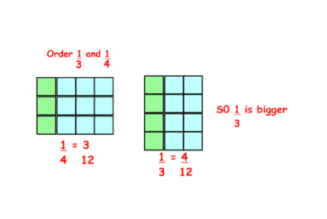
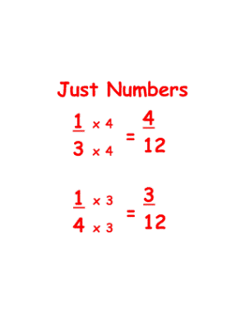
Use common factors to simplify fractions; use common multiples to express fractions in the same denomination.
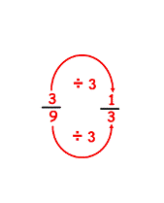
Use a common factor
to simplify

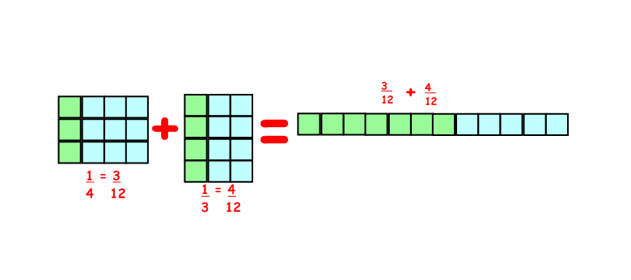
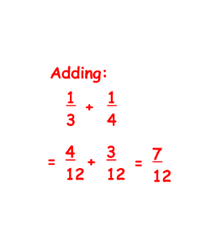
Add and subtract fractions with different denominators and mixed numbers, using the concept of equivalent fractions.

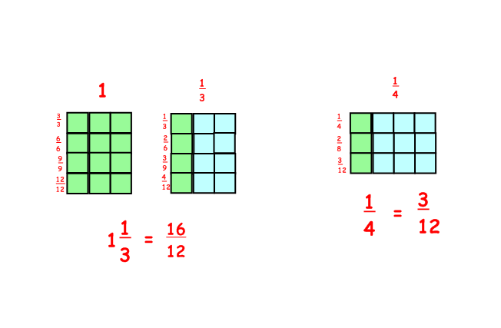
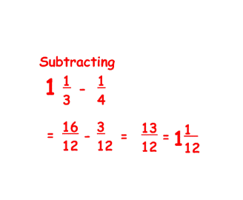
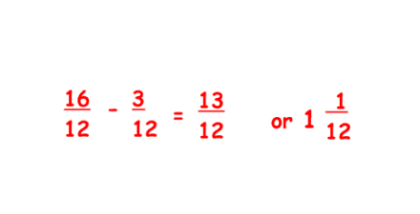

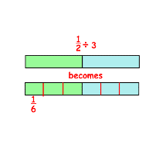
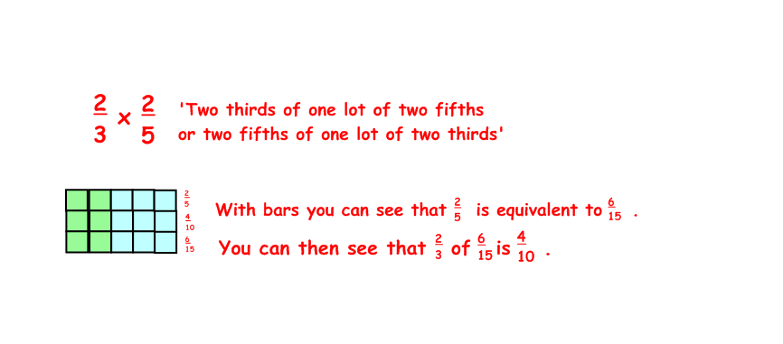
Multiply simple proper fractions and simplify the answer (e.g. ¼ x ⅟₂ = ⅟₈). Divide proper fractions by whole numbers (e.g. ⅓ ÷ 2 = ⅙).

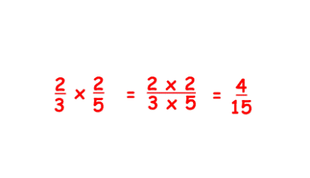
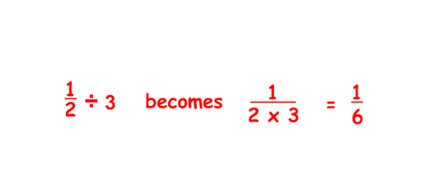

Ratio
Use mini bars to represent the given rations.
Identify the known totals.
Calculate the value of each bar.
Apply the value of each bar to find the answer to the question.
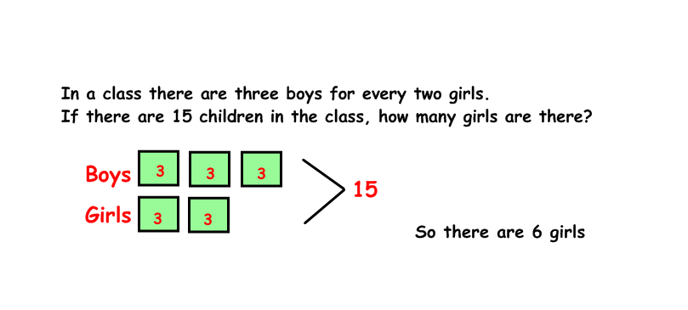
A.

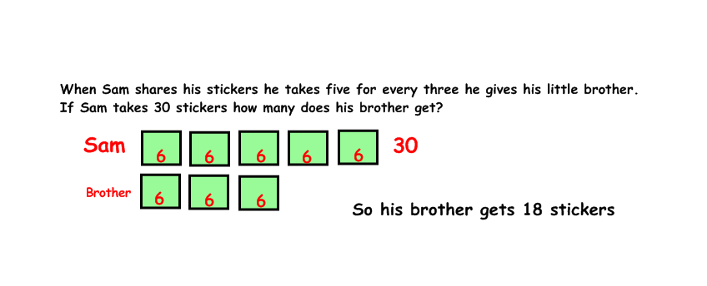
B.

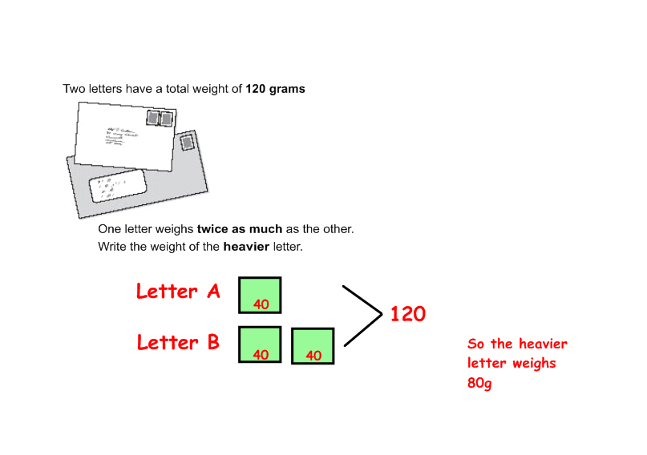
C.



